Main Dashboard:

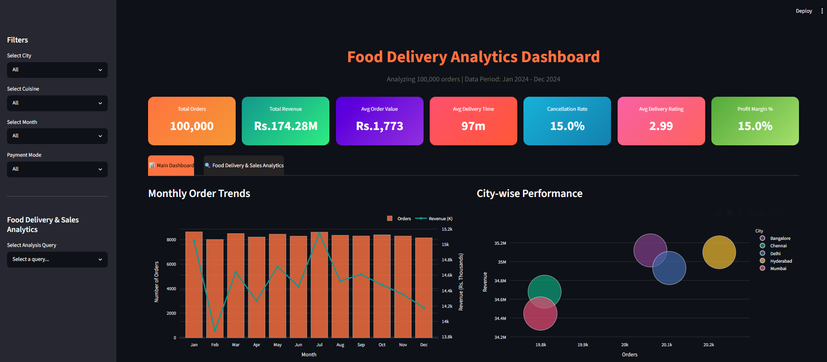
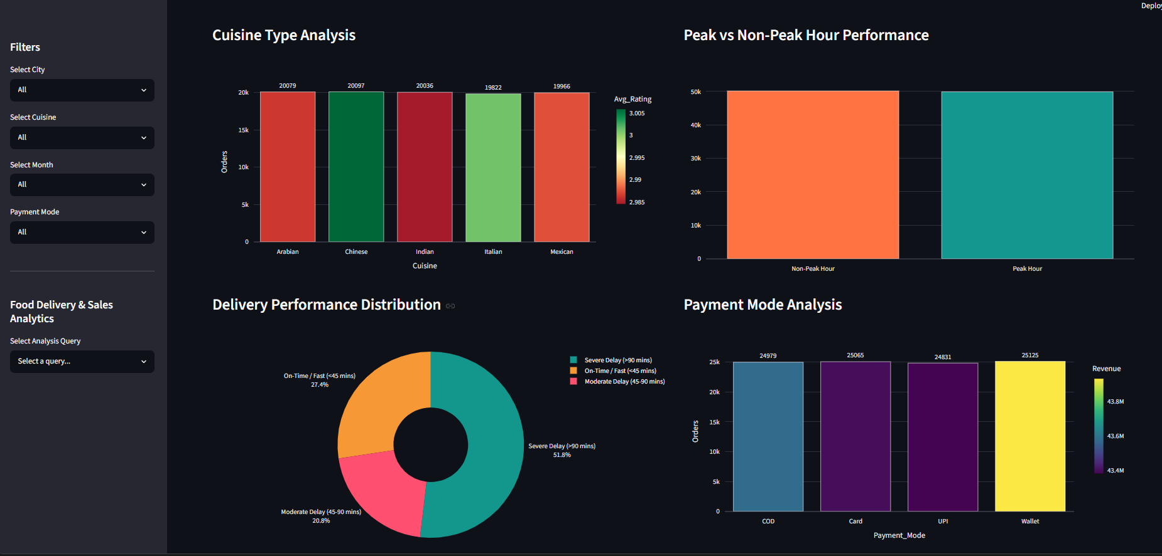
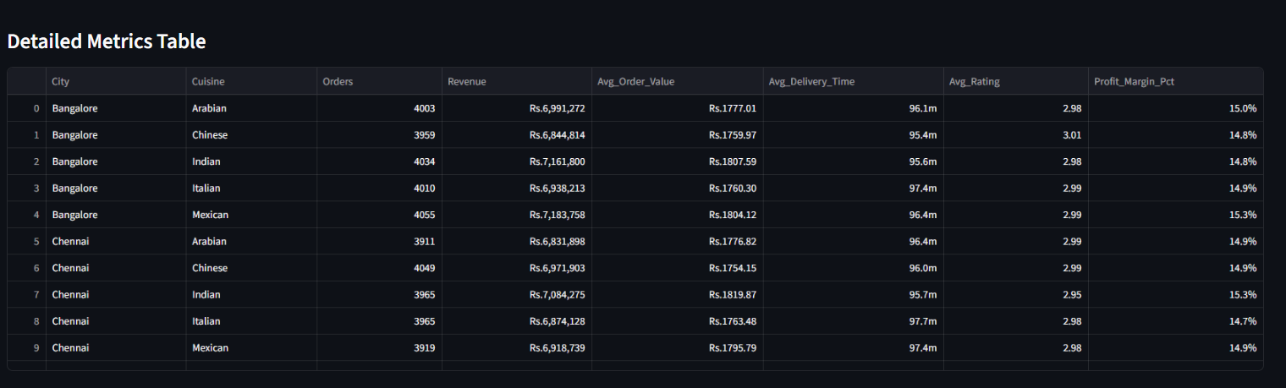

SQL queries (EDA & Analytics) :

Customer & Order Analysis
- Identify top-spending customers
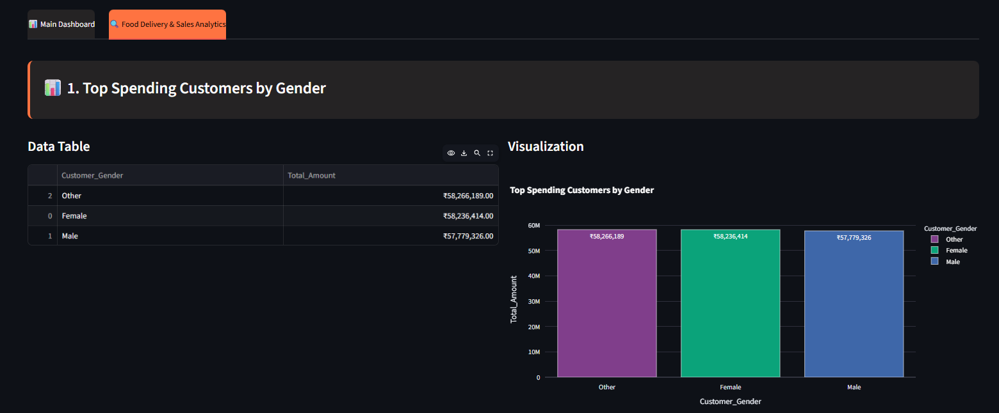
- Analyze age group vs order value
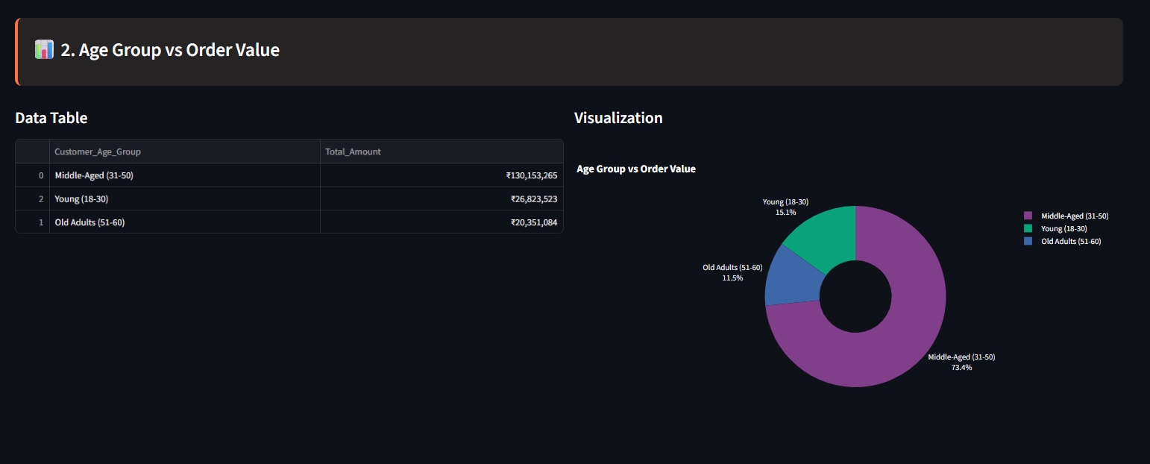
- Weekend vs weekday order patterns
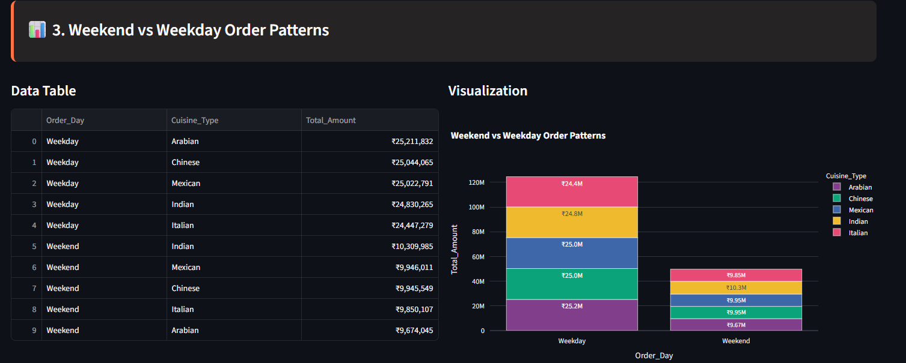

Revenue & Profit Analysis
- Monthly revenue trends
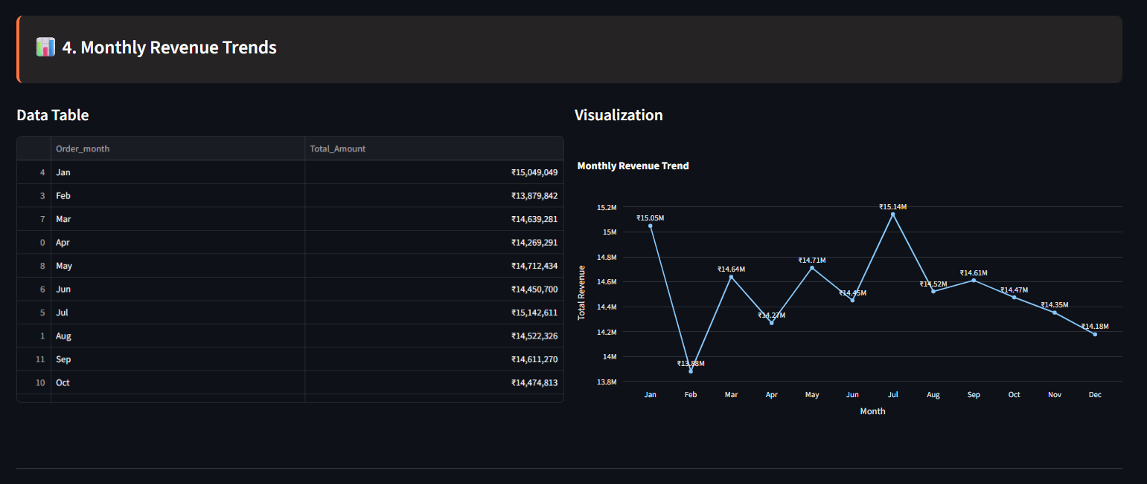
- Impact of discounts on profit
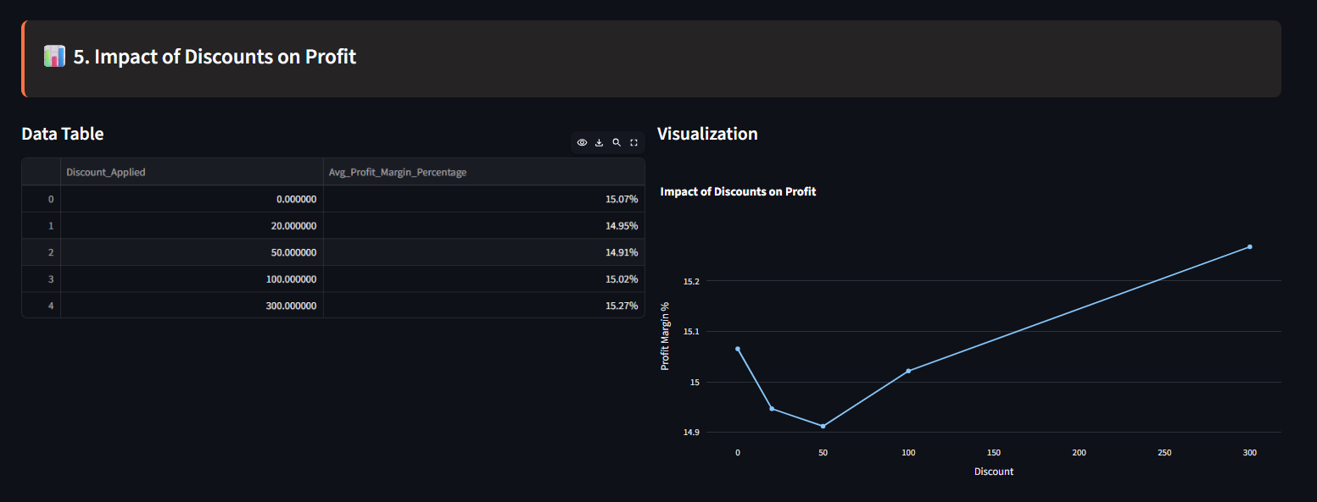
- High-revenue cities and cuisines
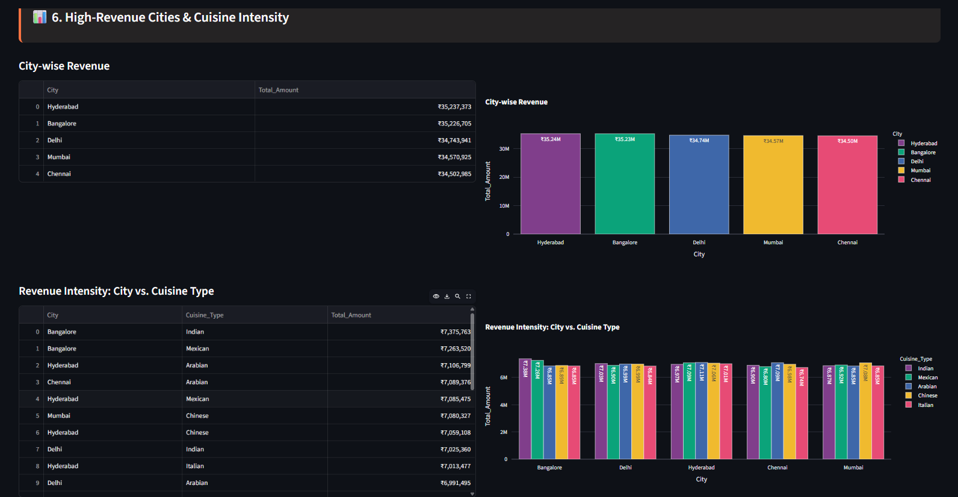

Delivery Performance
- Average delivery time by city
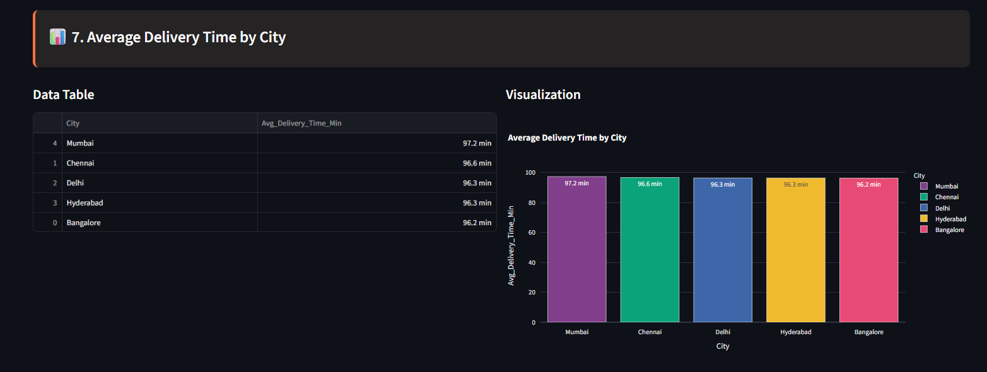
- Distance vs delivery delay analysis
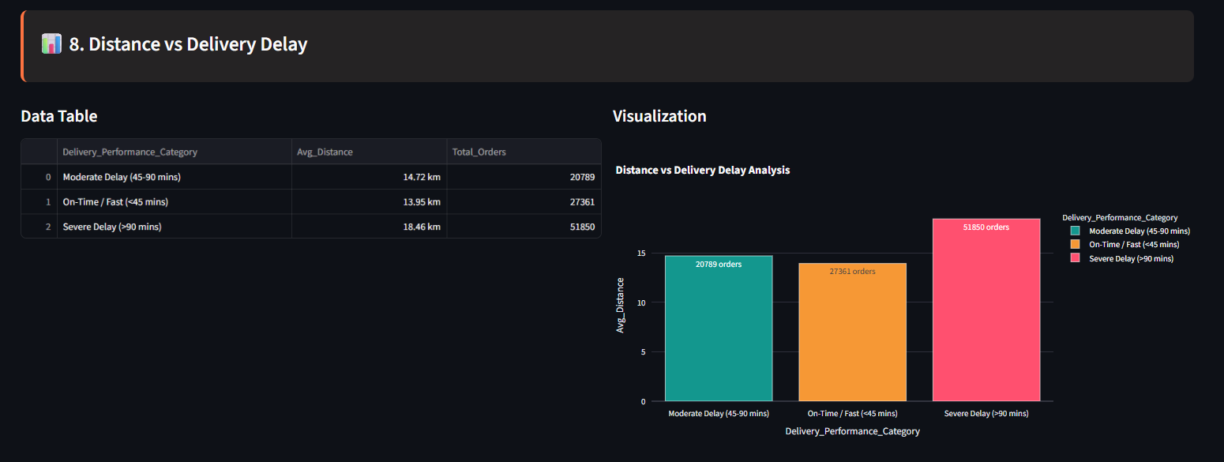
- Delivery rating vs delivery time
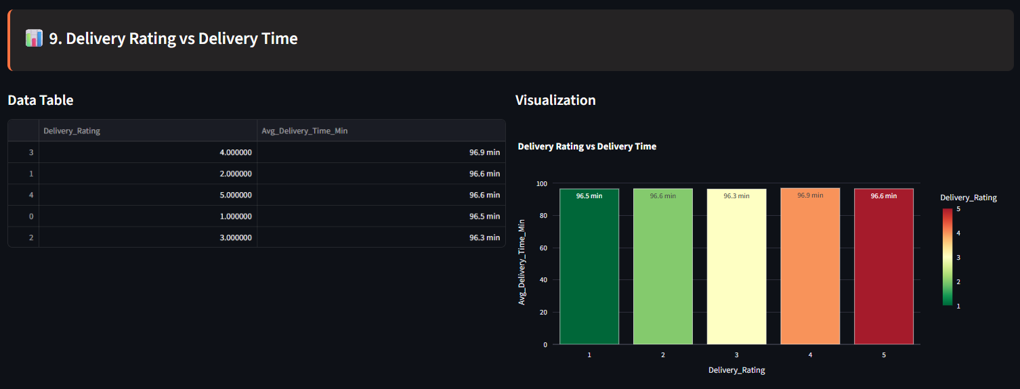

Restaurant Performance
- Top-rated restaurants
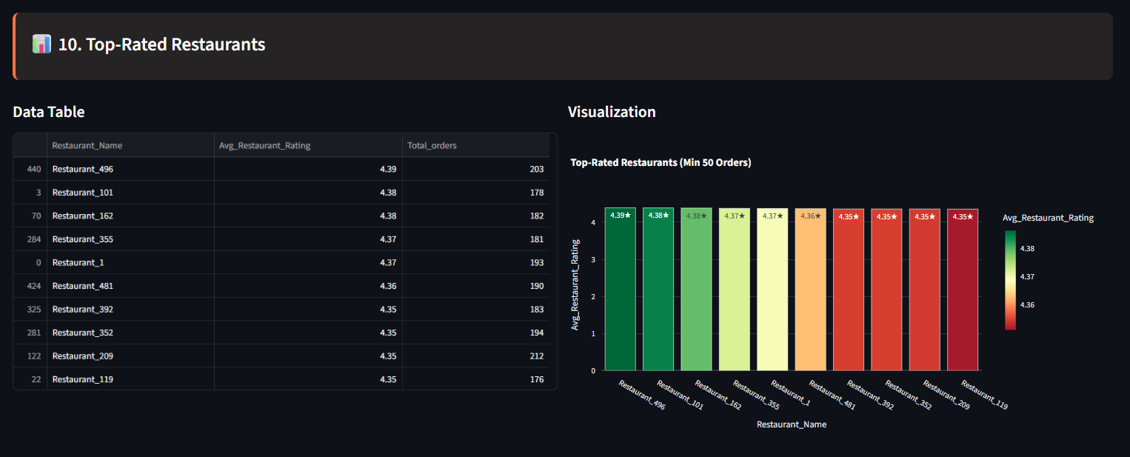
- Cancellation rate by restaurant
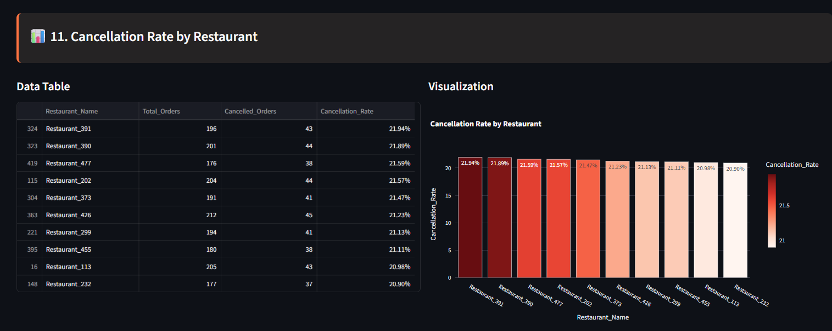
- Cuisine-wise performance
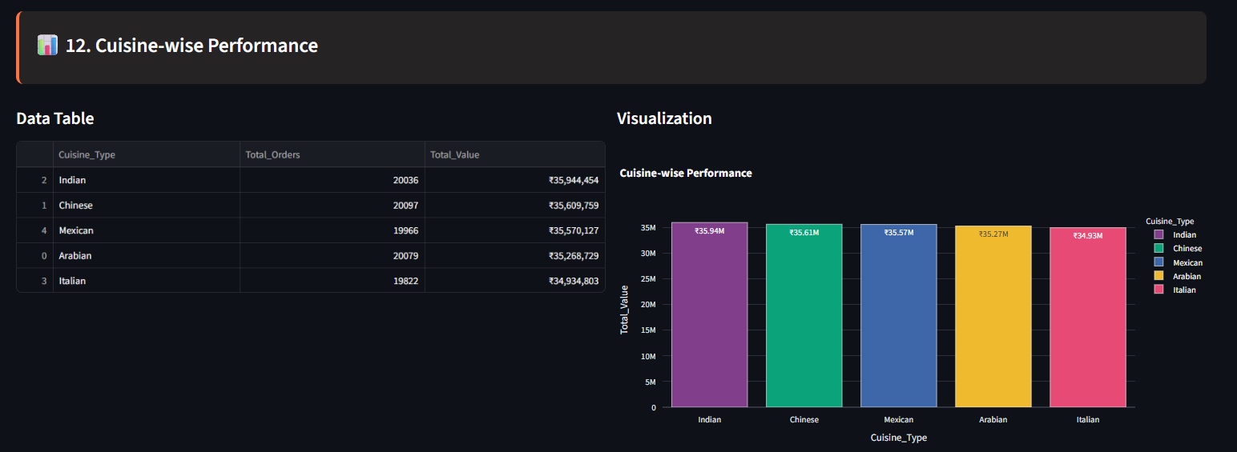

Operational Insights
- Peak hour demand analysis
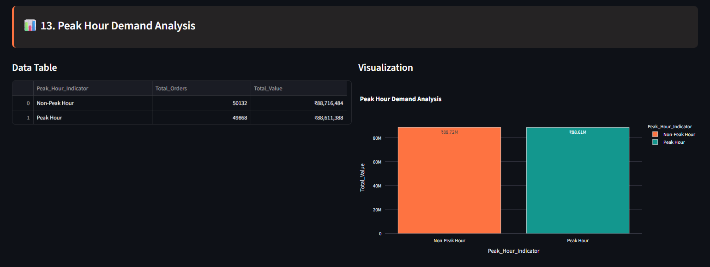
- Payment mode preferences
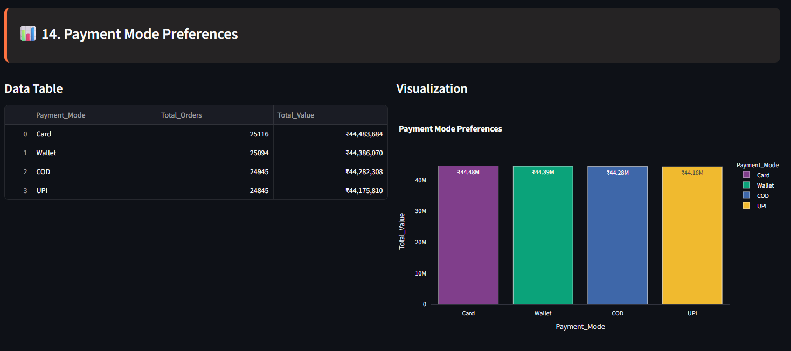
- Cancellation reason analysis
